Exp. No: 2
Determination and plotting of Electric field and Electric flux density in sphere full of charges with varying radius.
Aim:
To write program for electric field and electric flux density in sphere using
SCILAB.

Software required:
- SCILAB version 6.0.1

Program:

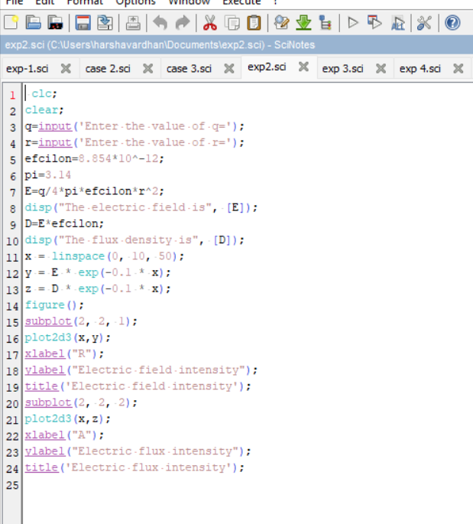
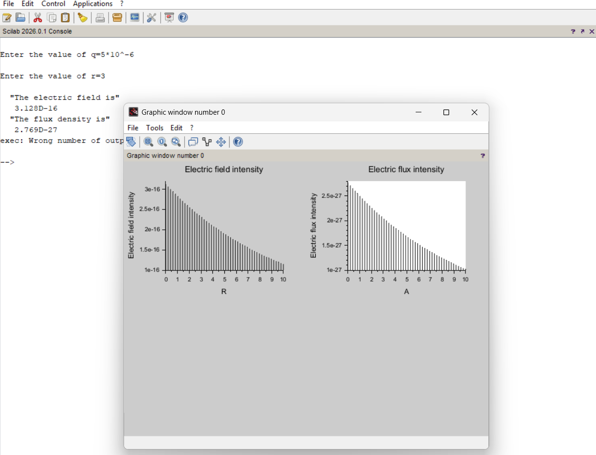


Output:-

Calculation:

